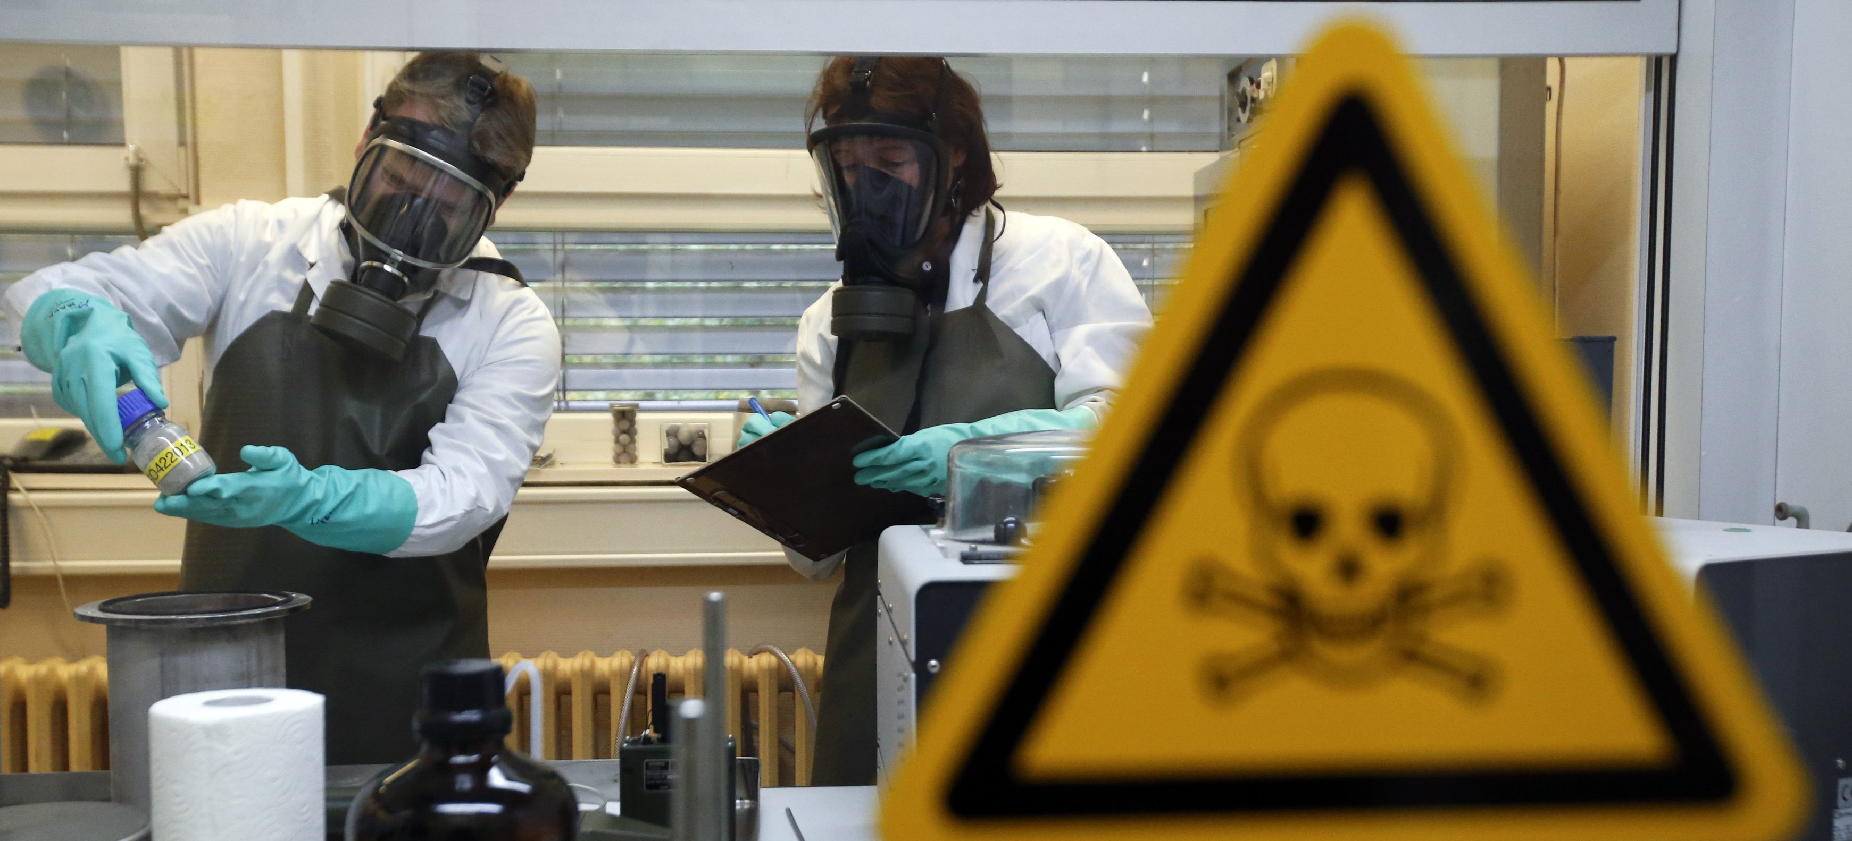
Research Report

World Health Organisation

The Question of Bioweapons

Background Information
The biological weapons convention entered into force on the 26th of March 1975, it prohibited the use of biological and toxin weapons. Despite this there remains an active threat from these devices, particularly if they were to be obtained by terrorist organisations or other non-state actors.
Diseases have been utilised in warfare by humans for centuries, with prominent examples being the proposed use of smallpox infected blankets in North America by the British during wars with various native American groups as well as the Mongols catapulting plague ridden bodies over castle walls during a siege in 1347.
However, in the modern period and with our more nuanced understanding of virology these weapons pose far more of a threat. Despite the signing of the 1925 Geneva protocol (which much like the biological weapons convention banned the use of biological weapons) biological weapons continued to be used and tested going into World War 2.
The biological weapons convention does seem to have limited the dissemination of biological weapons somewhat, however, there are still some countries accused of storing biological weapons although this has not been definitively proven.
A more pressing concern in the modern era is the use of biological weapons by terrorist organisations. The issue of biological weapons by terrorist groups is a somewhat modern phenomenon, examples include the Tokyo subway anthrax attack as well as the “anthrax letters” sent to some US politicians.
So far major death tolls have been avoided, mainly due to errors on the part of the terrorist groups in the making of their weapons. As information disseminates on the internet however it will only become easier for terrorist groups to obtain deadly biological weapons, unlike the amateurish creations that have been used before.
One significant fear is the possibility of bioweapons being captured by terrorist groups from countries with (Alleged) stockpiles. Little can be done about this without international cooperation as many nations will not submit to inspection as a matter of policy.
Bioweapons and the treat they pose can also be looked at from a “lab leak” perspective. Despite lacking conclusive evidence either way there remains suspicions that the Covid – 19 pandemic was the result of a leak (or even deliberate release) from the Wuhan virology institute. China denies such claims and they are mostly relegated to the level of conspiracy theorists, but the theory has been gaining traction over the last few months. Some argue that there needs to be more universal and stronger safety standards in biological testing institutes to ensure that there is no risk of a “lab leak” that could kill huge amounts of people.
The issue of bioweapons is a complicated one largely due to the secrecy of many of the nations involved. Some will not undergo UN inspection under any circumstances. Is it possible to strike some sort of deal with these countries? What can be done to ensure bioweapons do not fall into terrorist hands? Can the global community trust China when it says that it knows for certain that Covid 19 was not the result of a lab leak. These are the questions that must be answered if the issue of bioweapons is to be in any way resolved.

Useful Links:
https://libraryresources.unog.ch/bioweapons/undocs
https://www.who.int/health-topics/biological-weapons#tab=tab_1
https://www.nti.org/education-center/treaties-and-regimes/convention-prohibition-development-production-and-stockpiling-bacteriological-biological-and-toxin-weapons-btwc/
https://www.ncbi.nlm.nih.gov/pmc/articles/PMC1326439/
https://www.interpol.int/en/Crimes/Terrorism/Bioterrorism

