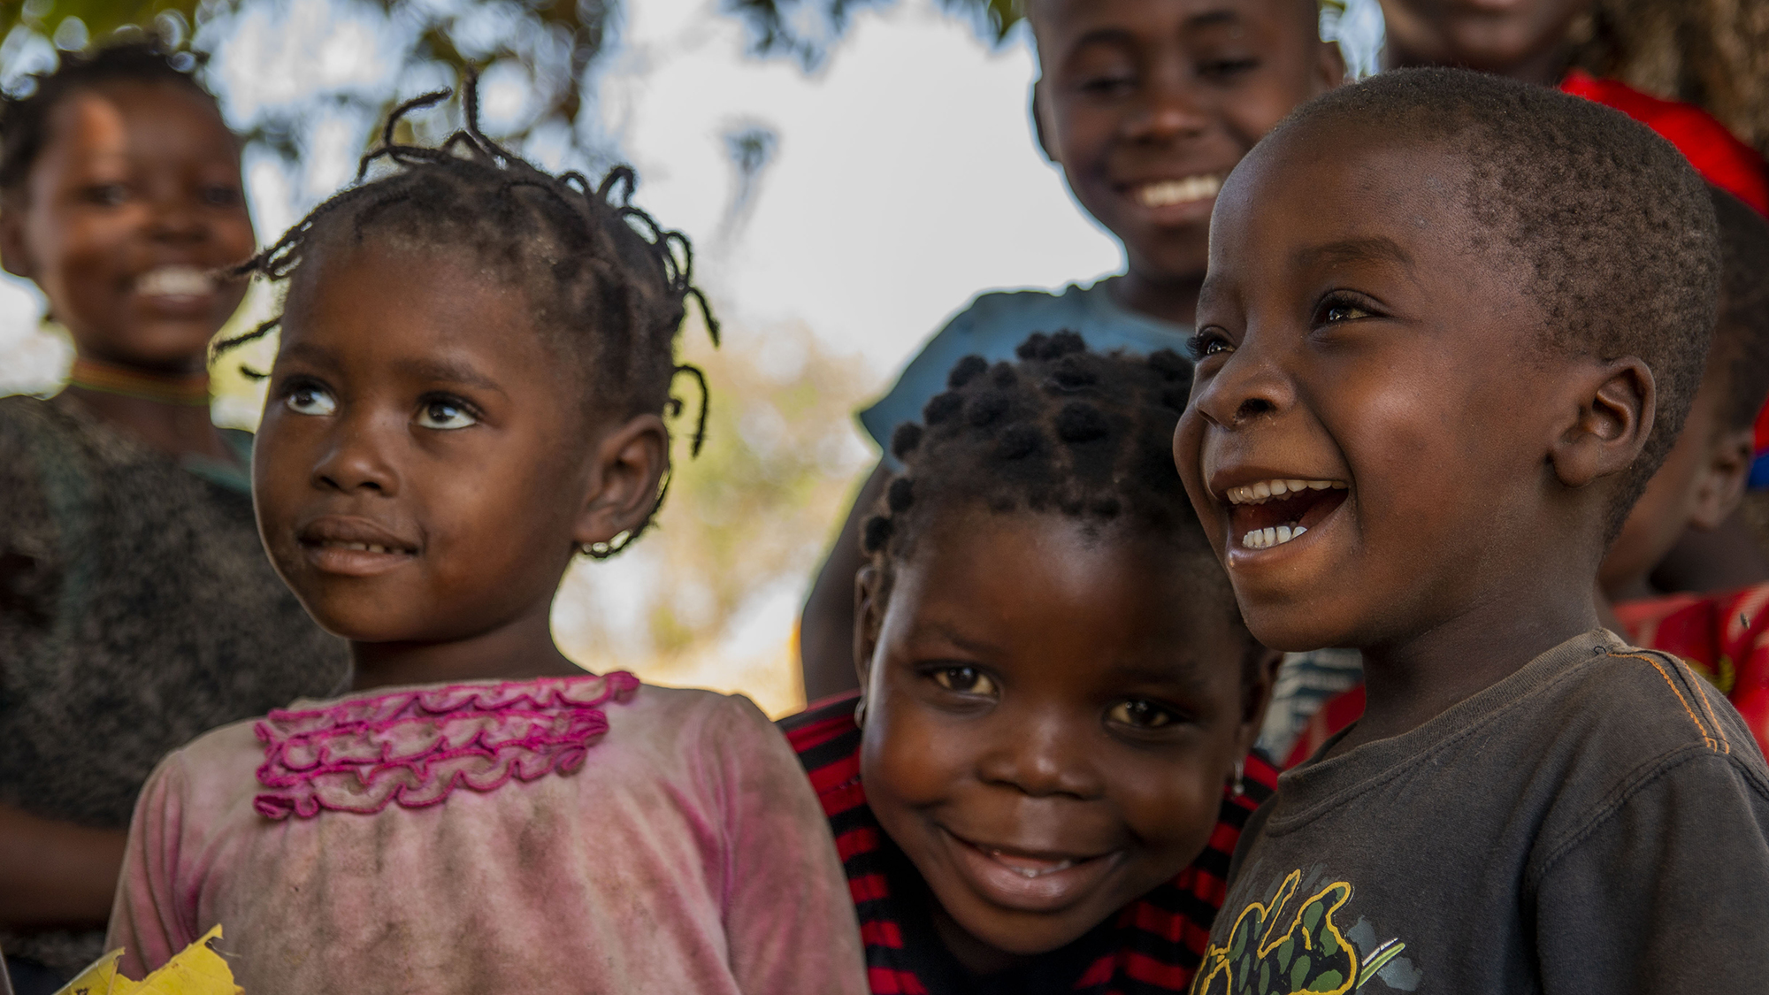
Research Report

United Nations Childrens Fund

Ensuring Children’s Health Through Improved Immunization

Background Information
Immunisation is key to achieving SDG 3, which aims to “ensure healthy lives and promote well-being for all at all ages” and therefore ‘we must do better’.
An estimated 67 million children missed out entirely or partially on routine immunization from 2019 to 2021. In Europe and Central Asia, this figure is 931,000 children.1 COVID-19 highlighted the overall weakness in health systems around the world and especially in rural or less developed areas and in particular weaknesses in the distribution of immunisation and in exacerbated the potential future problems on a global scale.
Despite successful immunisation against polio and smallpox and more recently immunisation against COVID-19, nations across the globe are in danger of outbreaks of vaccine-preventable diseases such as malaria and cholera as a result of climate change. New communities are being exposed to these diseases and do not have the vaccines, or skilled manpower to disseminate those vaccines. Additionally, vaccine misinformation is readily available through the huge range of social media platforms making it even harder for the uptake of immunisation when it is available. This will have a disastrous effect of economies especially if the future labour force is depleted through death or physical disability.
Covid -19 was a reminder that lack of immunisation in countries across the globe is not just a matter of infrastructure, instead it is a matter of political will. Until governments not only understand but also accept that SDG 3 is connected to all the other SDGs, this goal will never be met. The Covid-19 vaccination distribution should also be used as a reminder of the progress that can be made when global nations work together and when national and local organisations have the same focus and intended outcome.

Issues
Low socioeconomic areas have a prevalence of ZERO DOSE. This means that children in these areas will not receive any vaccinations while in Europe and Asia, there is a prevalence of UNDER-VACCINATED which means here some children receive some of the immunization. Low uptake in these areas is mainly due to misinformation and cultural hesitation.

Key Questions
Identifying ‘zero-dose’ and ‘under-vacinated’ areas
Identifying ways to address the inequitaies in these areas identified above
Developing better ways to record individual child-health systems
Developing infrastructure to ensure availability and distribution of vaccines especially on areas of inequity
Improving communication and confidence in vaccines increase the uptake.
Investing in primary health
Improving donor support

Countries Involved
India, Pakistan, Ukraine, Nigeria, Ukraine, United States, France, Israel

