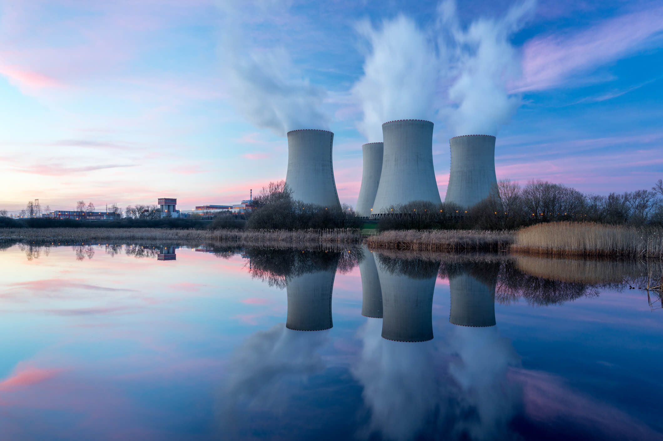
Research Report

Disarmament and International Security

The Question of The Proliferation of Nuclear Technology To Non-Nuclear Nations

Background Information
In recent years the number of nuclear powers has dramatically increased across the world with the number of nuclear powers now totaling at nine with it estimated that over ten countries posses the means to develop such weapons in the future if they desire, some of which have already started this program. With this in mind, the UN would like to encourage the discussion among nations towards the de-nuclear weaponization of countries across the world and to help deter non-nuclear nations from acquiring nuclear weapons or weapons of mass destruction involving nuclear technology.

Issues
Countries such as Iran are actively suspected to be trying to develop nuclear weapons. This is in response to the increase in nuclear weapons in the region such as the perceived Israeli stockpile of nuclear weapons increasing. The UN is advising all countries co-operate to find a solution that deters non-nuclear nations from trying to gain nuclear weapons as well as reducing the need for them to possess them by countries currently in possession of nuclear weapons taking steps to reduce this need.
Some countries such as Japan, the Netherlands and Germany are examples of countries which have the capability to develop nuclear weapons but do not feel the need to pursue this mission so should be looked at as an example of why this is the case. In addition, South Africa serves as a shining example of a country which once was a nuclear weapon state giving up its nuclear weapons.

Key Questions
Delegates should consider how best to address the increase of the development of nuclear weapons from non-nuclear weapon nations.
Delegates could seek to address the increase in the desire of countries to posses nuclear weapons due to other countries actions.
Delegates should consider the extent of the UN regulation and deterrence for non-nuclear weapon states to pursue these goals needed to maintain peace and security worldwide.
Delegates could consider the implications, positive and negative, of nuclear energy, with a particular focus on the potential for weapons the technology holds.

Countries Involved
USA, Iran, Israel, China, Russia, UK, France, Pakistan, India and DPRK

Useful Links:
https://www.armscontrol.org/factsheets/Nuclearweaponswhohaswhat
https://en.m.wikipedia.org/wiki/Treaty_on_the_Prohibition_of_Nuclear_Weapons

