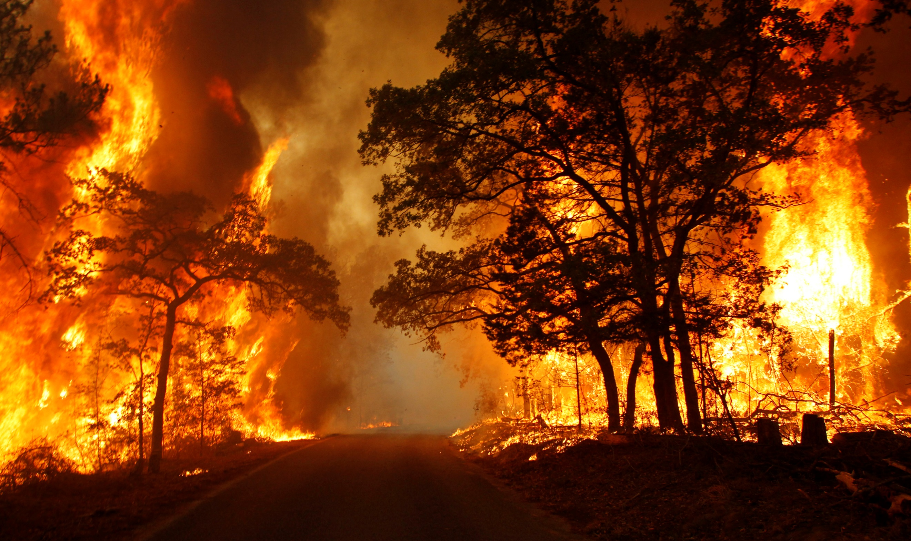
Research Report

Environmental Committee

The Question of Disaster Response to Extreme Natural Events

Background Information
With the rapidly increasing temperature of the world, globally, there has been an ever increasing rate of extreme weather and other natural events, including forest fires. In the USA, torrential downpour, rising sea levels and rampant flooding are clear examples of this. With the increasing frequency of life-threatening disasters and cataclysms, many believe that global discourse needs to shift to addressing how the nations of the world go about responding to such events in the future. In addition, conversations must be had about how to prevent the damage and loss of life from an event through preparation and infrastructure which can save lives when such events occur.

Issues
There are many difficulties with responding to natural disasters, such as the expensive nature of implementing solutions, as well as the lack of labour available to respond and try to offset the damage. In addition, since these factor are all simply about dealing with disasters after they occur, but at this point many lives have already been lost, it is also important to consider how we can prevent such damage from occurring in nations at risk in the first place. It is also crucial that Member States agree on what can be done in terms of international aid to countries experiencing disasters, and the way that this can be affected by warfare and sanctions imposed by nations.

Key Questions
How can funding be made readily available for nations at risk from environmental and tectonic hazards?
How can nations find the workers required for the large-scale manual labour involved in disaster response?
What preparations can be put in place to prevent lives being lost during the immediate course of a disaster?
How can vulnerable cities and countries more broadly prevent damage to buildings and infrastructure, which can ruin the lives of those who are not lost to extreme natural events?
How do warfare and sanctions affect the way nations respond to disastrous events in other member states, and what can be done overcome the problems this poses?

Countries Involved
USA, UK France, China, and any Member State, particularly LEDCs,

Previous Attempts to Solve the Issue
The 2015 Paris Agreement is a significant UN initiative to mitigate the effects of climate change, aiming to reduce the frequency and severity of extreme weather events by implementing polices.
The Sendai Framework (2015-2030) for disaster reduction was adopted at the Third UN World Conference on Disaster Risk Reduction in 2015 and set out a 15-year plan to reduce disaster risk. It provokes the importance and need of understanding disaster risk, as well as strengthening resilience, and reducing disaster mortality that may occur in addition to mitigating any economic losses.
The UN Office for Disaster Risk Reduction (UNDRR) plays an important and central role in coordinating and supporting disaster risk reduction efforts in the International community, working closely with member states, international organizations, and NGO’s to promote resilience and response to natural disasters.

Useful Links:
https://en.wikipedia.org/wiki/Disaster_response
https://msf.org.uk/issues/natural-disasters
https://www.internetgeography.net/topics/immediate-and-long-term-responses-to-tectonic-hazards/#:~:text=Short%2Dterm%20responses%20mainly%20involve,%2C%20schools%2C%20hospitals%2C%20etc.
https://www.dec.org.uk/
https://en.wikipedia.org/wiki/Human_response_to_disasters

